CIS328 Team Project Final Report

Fitness and Health Analytics

A Statical Exploration of Workout

Behavior and Body Metrics

Course: CIS328

Instructor: Jinjuan Feng

Team Members:
- Niranjan K C
- Pradip Raj Dhakal
- Jivitesh Marken

Date: May 13, 2025

Section 1: Problem Definition
This project analyzes gym member data to understand workout behavior and predict session duration. Specifically, the team focused on comparing multiple means using ANOVA tests, and modeling relationships using multiple linear regression.
We chose the gym members exercise tracking dataset because it contains a variety of meaningful health and fitness variables like workout type, calories burned, fat percentage, and workout frequency. These are real-world, measurable factors that allow us to apply statistical analysis techniques such as ANOVA to compare group means and understand patterns in physical activity and health outcomes. The dataset also has multiple conditions (e.g., workout types and frequencies), which made it ideal for testing hypotheses with ANOVA and exploring relationships using regression modeling in the second part of the project.

Section 2: Dataset Description and Exploration
The dataset includes variables such as Calories Burned, Fat Percentage, Session Duration, Workout Type, Workout Frequency, Gender, Age, and other biometric and workout-related attributes. Descriptive statistics and visualizations were conducted to explore variable distributions.
The descriptive statistics obtained from R-studio about our dataset:
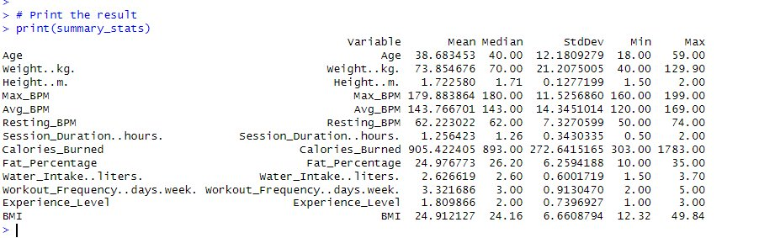
Here are some visualizations using Tableau.
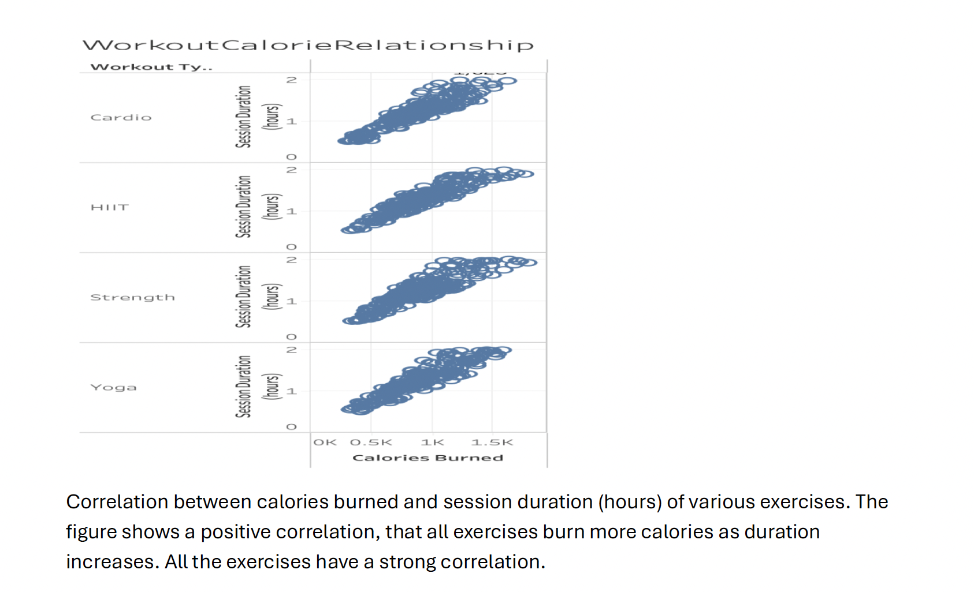
Correlation between calories burned and session duration (hours) of various exercises. The figure shows a positive correlation, that all exercises burn more calories as duration increases. All the exercises have a strong correlation.

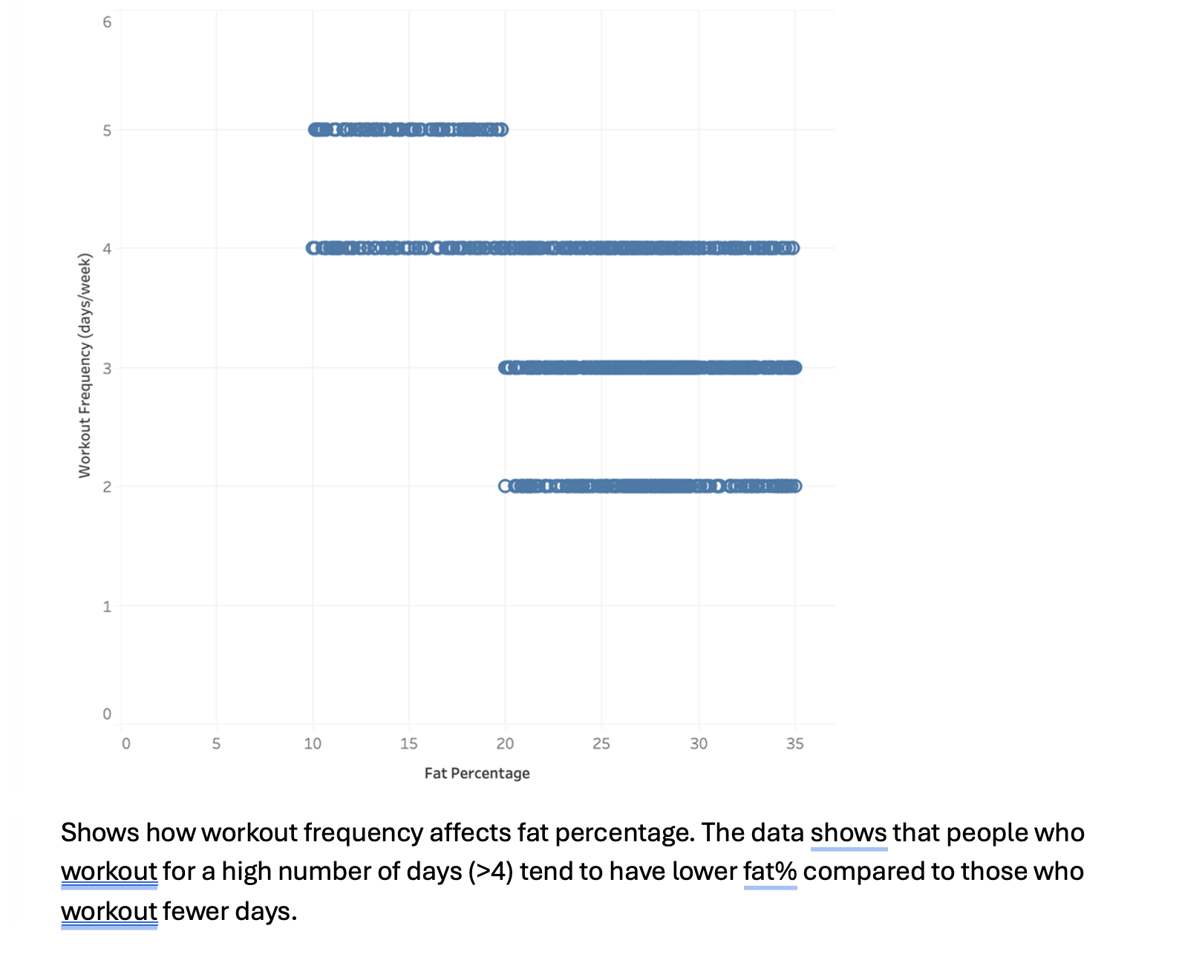
Shows how workout frequency affects fat percentage. The data shows that people who work out for a high number of days (>4) tend to have lower fat% compared to those who work out fewer days.

Section 3: Hypotheses and Research Question
ANOVA Test 1 Hypothesis: Calories burned differ by workout type (Cardio, HIIT, Strength, Yoga).
ANOVA Test 2 Hypothesis: Fat percentage differs by workout frequency (2, 3, 4, 5 days/week).
Research Question: What variables significantly predict gym session duration?

Section 4: Comparing Multiple Means (ANOVA Tests)
ANOVA Test 1 was conducted to compare Calories Burned across Workout Types. Assumptions of normality and homogeneity of variances were checked. The result was not statistically significant (F (3, 969) = 0.949, p = 0.416).
Descriptive stats of Calories burned by Workout Types
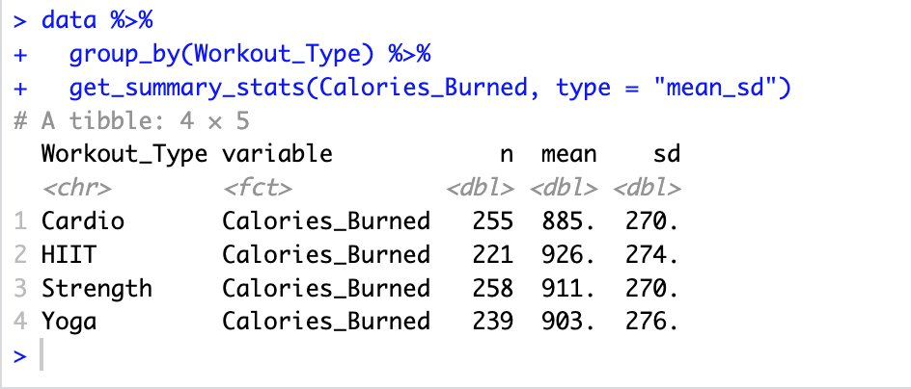
Although there are differences in the group means, the standard deviations are similar across all groups, indicating relatively consistent variation.
The distribution of calories burned by workout types through box plot:
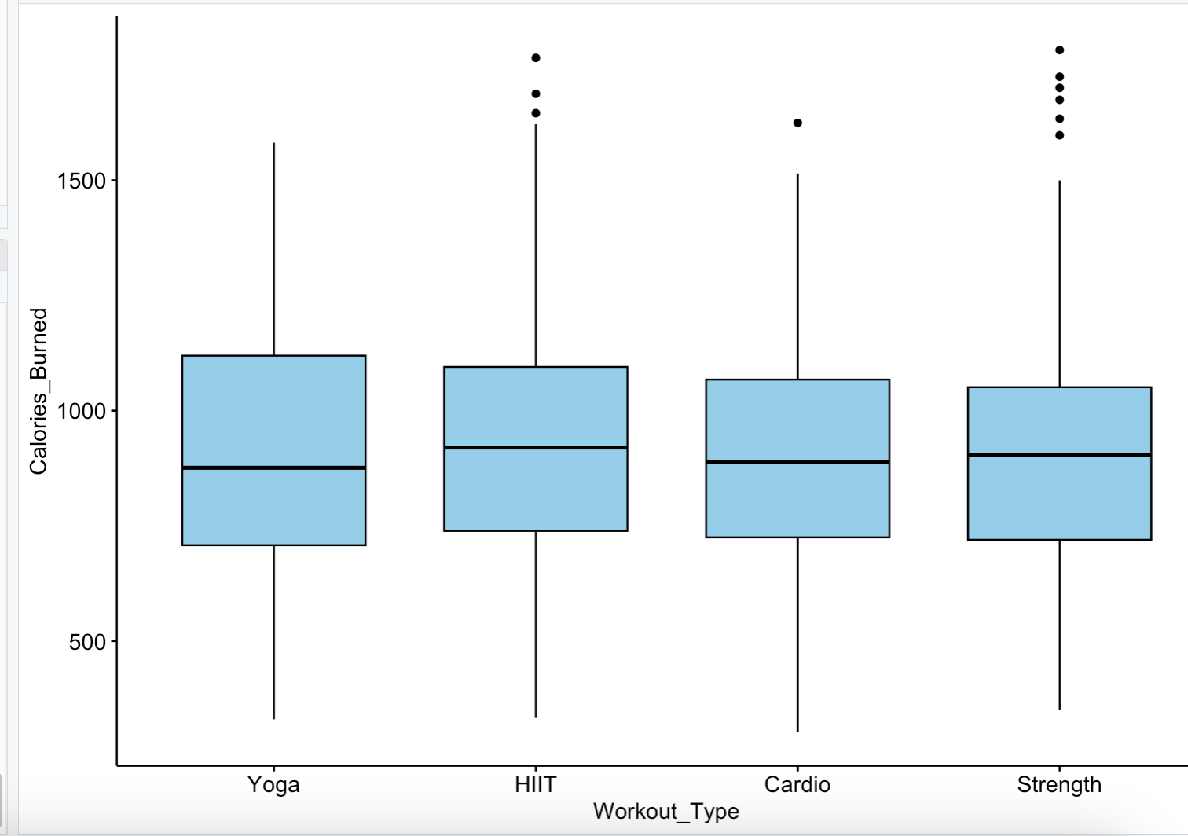
All workout types have a similar spread (IQR), with visible outliers​
HIIT and Strength have more upper outliers (burning high calories)​
Shapiro-Wilk -Test
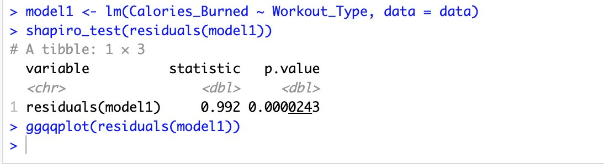
QQ Plot for normality test.
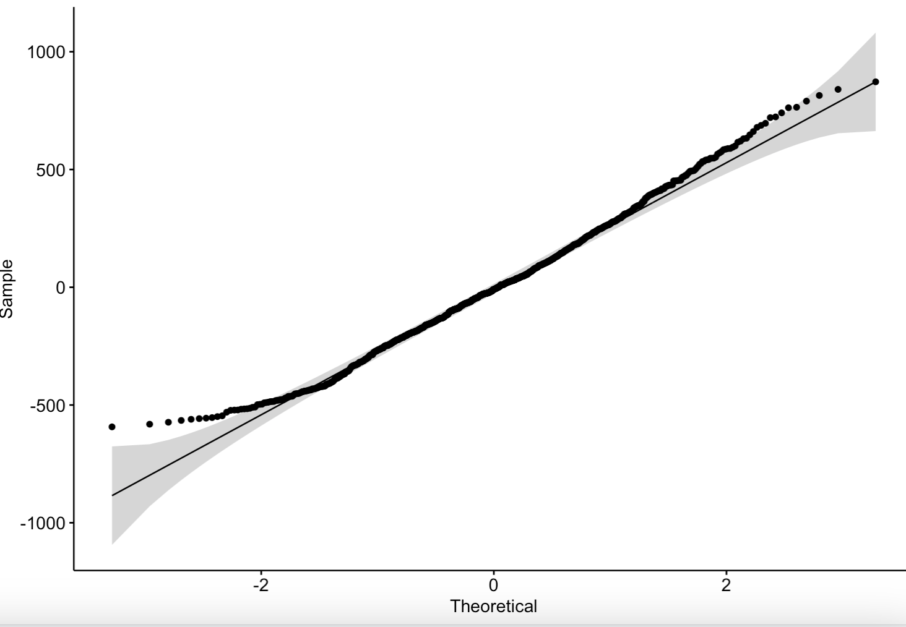
The p-value from the Shapiro-Wilk test is less than 0.05, suggesting the residuals are not perfectly normal.​ However, the QQ plot shows that the residuals align reasonably well with the theoretical normal line, so the assumption is met for normality.
Levene’s Test to check for homogeneity of variance.
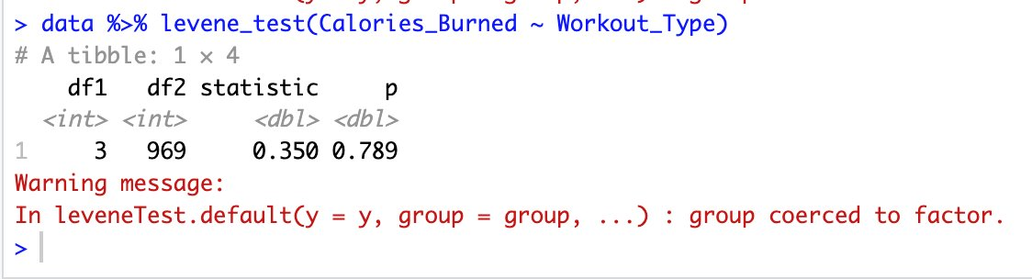
Assumptions met. Now testing Anova:
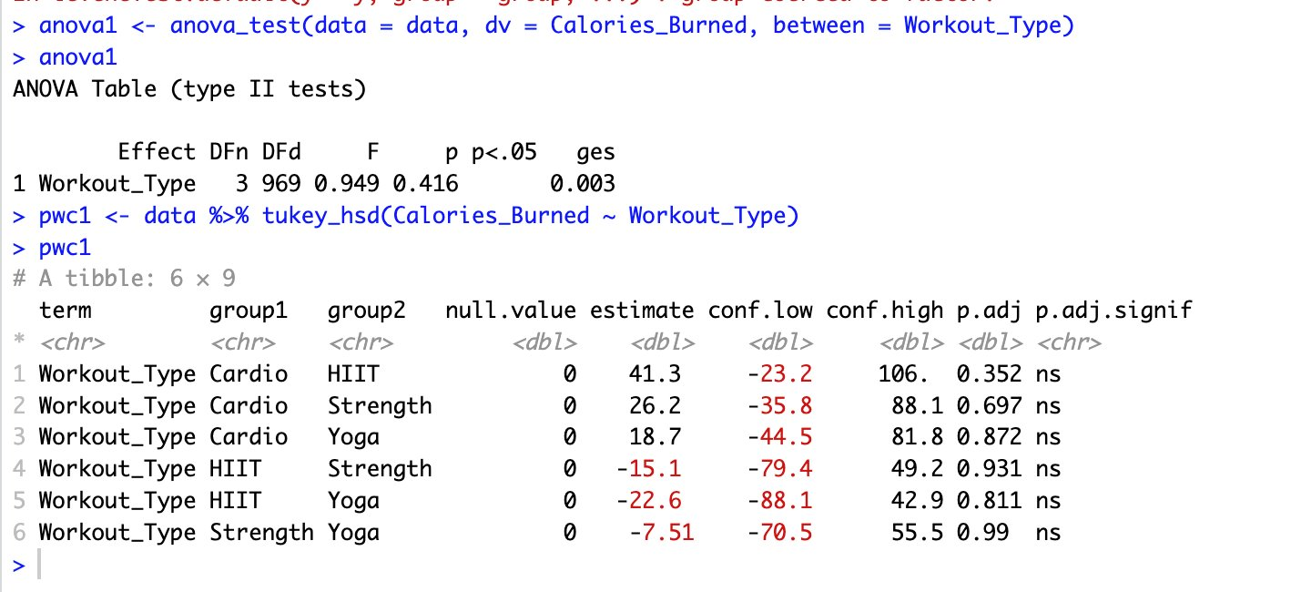
The one-way ANOVA test showed no significant difference in means between the four workout types.
Conclusion: We fail to reject the null. Null (H₀): There is no significant difference in mean calories burned across workout types (Cardio, HIIT, Strength, Yoga).​

ANOVA Test 2
Examined Fat Percentage across Workout Frequency groups. Levene’s test indicated violation of homogeneity, but the ANOVA result was highly significant (F(3, 969) = 211.52, p < 0.001). Tukey’s test showed significant differences among most group comparisons except between 2 and 3 days/week.
Descriptive stats of Fat Percentage by Workout Frequency
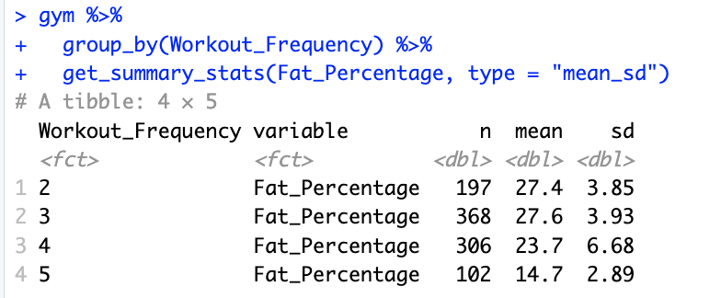
The standard deviation is slightly higher for 4 days/week, suggesting more variability in that group.​
This descriptive summary suggests that working out more frequently may be associated with lower body fat.​
Box plot of Fat-Percent grouped by Workout_Frequency.
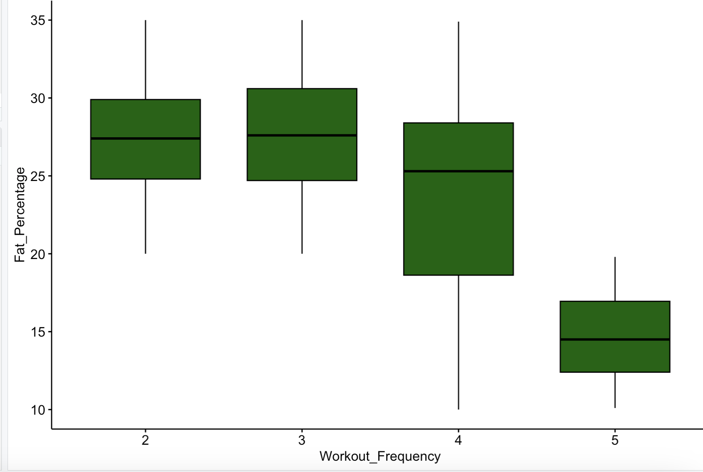
Normality Test (Shapiro-Wilk): The p-value was < 0.001, indicating the residuals are not normally distributed.​
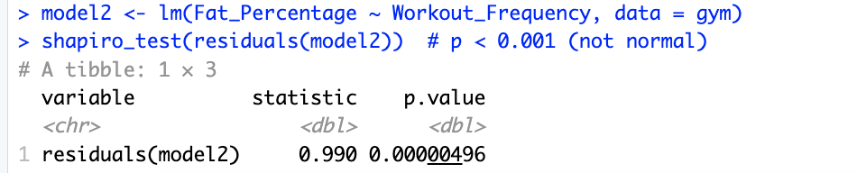

QQ Plot: The data points follow the trend line fairly well, suggesting that normality is approximately met visually.​
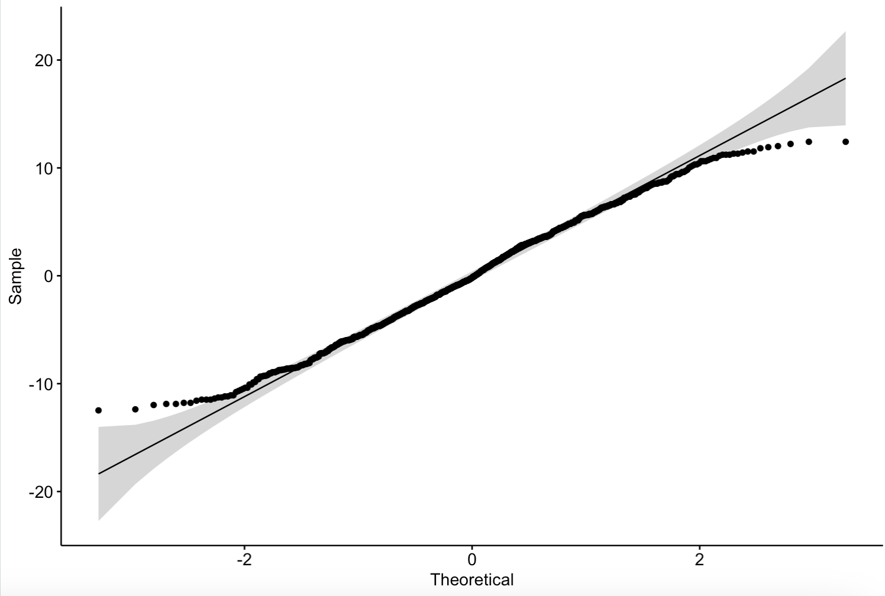
Levene’s Test to check for homogeneity of variance.
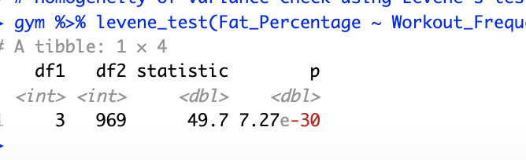
Variances are not equal across groups as indicated by the test. We proceed with transforming the data to log and then test the homogeneity of variance again:-
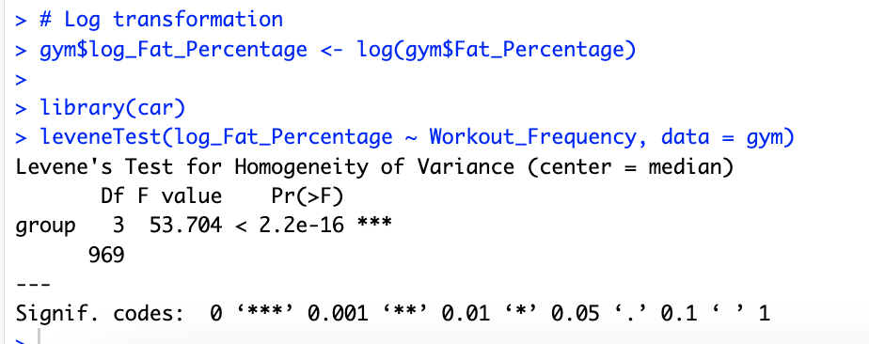
We see that the p-value is still high even after transforming the Fat_Percentage to log. That means we fail to reject the null hypothesis that the group variances are equal. This is a violation of the assumption of homogeneity of variances for anova test. At least one group has a different variance. That could most likely be group (4-day Workout Frequency) as seen at the box plot earlier.
- Null Hypothesis: There is no significant difference in mean fat percentage across workout frequencies (2, 3, 4, or 5 days/week).​
Therefore, we use the non-parametric test such as the Kruskal-Wallis Test to find the answer:
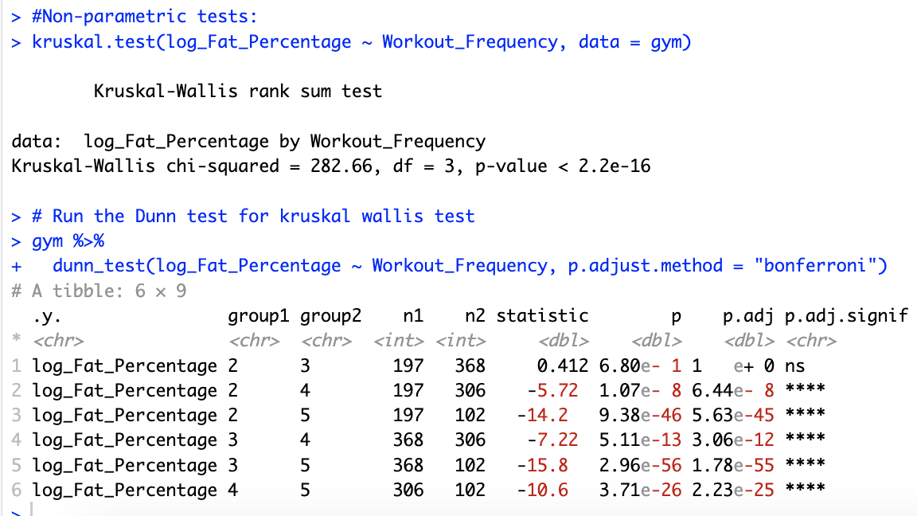
The test shows a high p-value, indicating that there is no statistically significant difference between the group mean, but we don’t know exactly among which group/s it is. Therefore, we run the post hoc Dunn test. The result states that except 2- and 3-day workout frequency, every other group had significant p values, with 3 and 5 having the highest p-value. This means that there is no difference in the means of fat percent of people who work out 2 and 3 day per week. However, there is a difference in every other day. People working out 3 days and 5 days have the biggest mean fat percent difference.
Conclusion: We reject the null. Null (H₀): There is no significant difference in mean fat percentage across workout frequencies (2, 3, 4, or 5 days/week) and accept the alternative. Alternative (H₁): At least one frequency group has a different mean fat percentage. Alternative (H₁): At least one frequency group has a different mean fat p

Section 5: Multiple Linear Regression
Model 1 included all predictors. It explained 97.57% of the variance in Session Duration. Significant predictors included Experience Level, Calories Burned, BMI, Age, Gender, Resting BPM, and others. Diagnostic plots confirmed linearity and normality of residuals.
Diagnostic plots with all predictors and Session_Duration as the response.

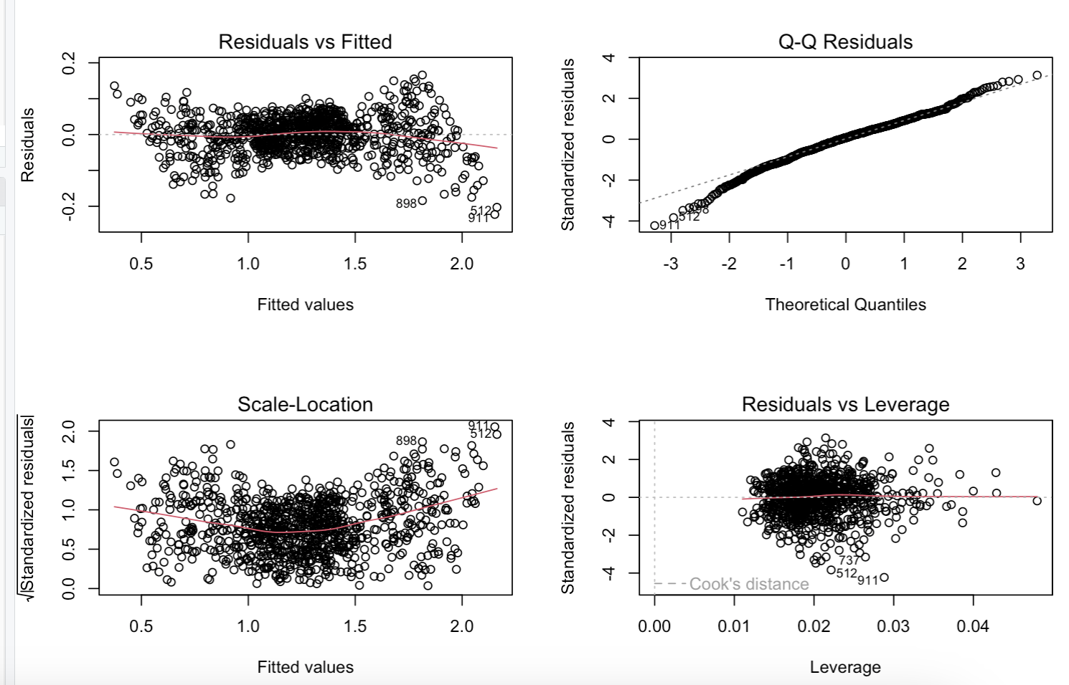
If the relationship is linear, the red line should be close to a horizontal straight line which it is in the scale-location plot. Since the data points form a line that is not curved and doesn't deviate from the reference line in qq-plot, the data is most likely normally distributed. Since the red residual line is slightly curved and deviates from the reference line, the relationship between X and Y is not strictly linear. There are many outliers, but few are influential.
Checking some interaction effects:
The interaction between calories burned and height on the amount of time people spend at the gym.
lmi2.fit = lm(Session_Duration~Calories_Burned*Height, data = gym)
summary(lmi2.fit)
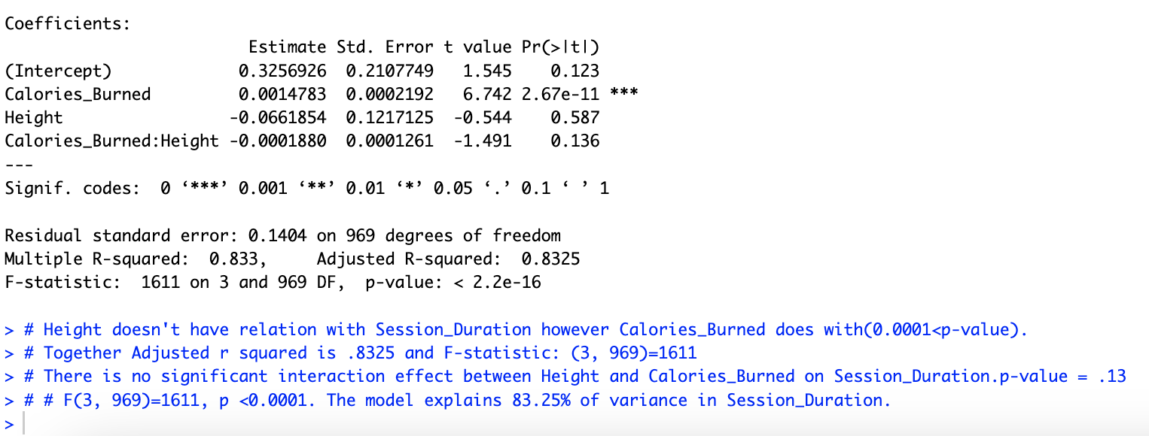Inference: Both the variables combined explained 83% of variance and a high F statistic says the model overall regression model is statistically significant. However, there is no relationship between calories burned and height on session duration, as indicated by p-value of >.05.
Interaction between Fat percentage and experience level on calories burned by people at the gym.
lm9.fit = lm(Calories_Burned~Fat_Percentage*Experience_Level, data = gym)
summary(lm9.fit)
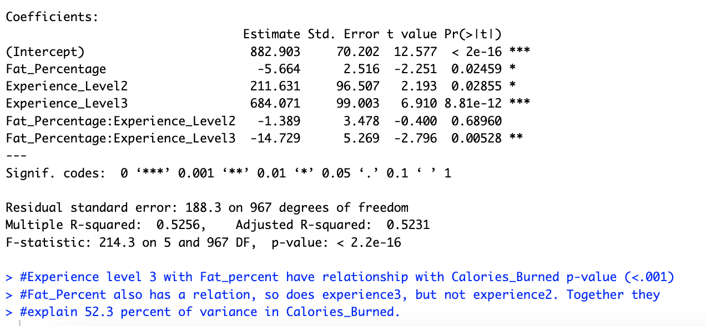Inference: There is a strong interaction effect between some experience level (3) and Fat percentage on Calories burned. Model has a high F-statistic (214 on 5 and 967) which means the model explains large portion of variation on calories burned. Adj R-sq. = 52%.
Interaction between Weight and Session_Duration on Calories_Burned.
lmu11.fit = lm(Calories_Burned~Weight_kg*Session_Duration, data = gym)
summary(lmu11.fit)
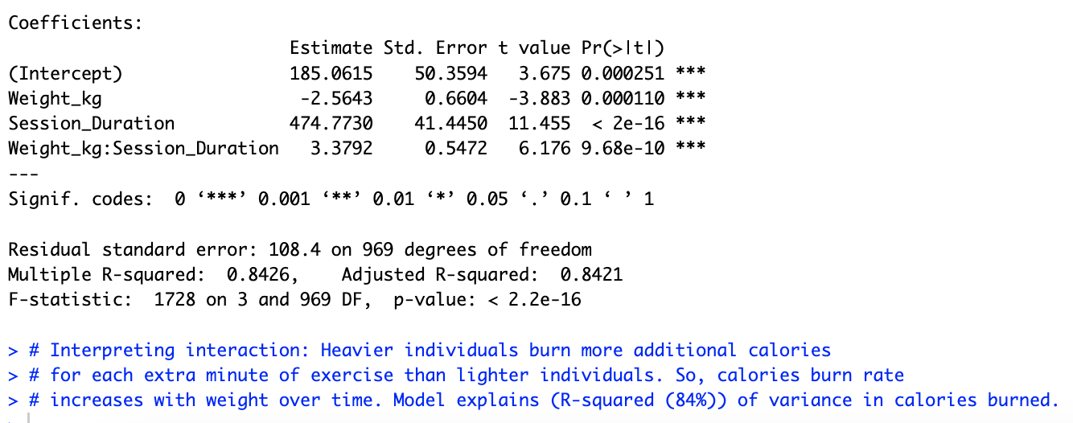
Model 2 included only the significant predictors. It retained a similar level of model accuracy. Key interactions were explored (e.g., Weight * Calories Burned), and prediction intervals were calculated for Session Duration and Calories Burned.
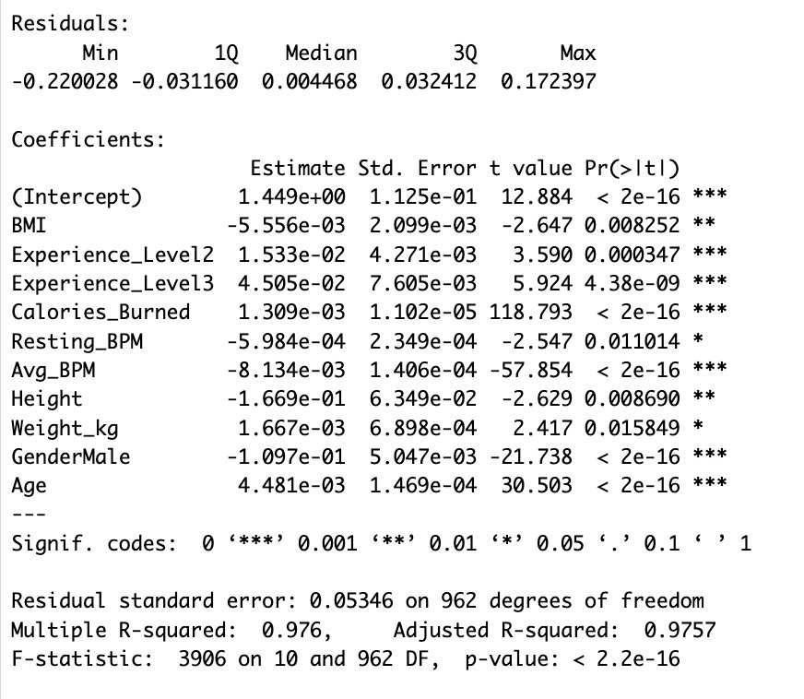z
Adjusted R- Squared is 97.57%. F-statistics is 3906 on (10 and 962)
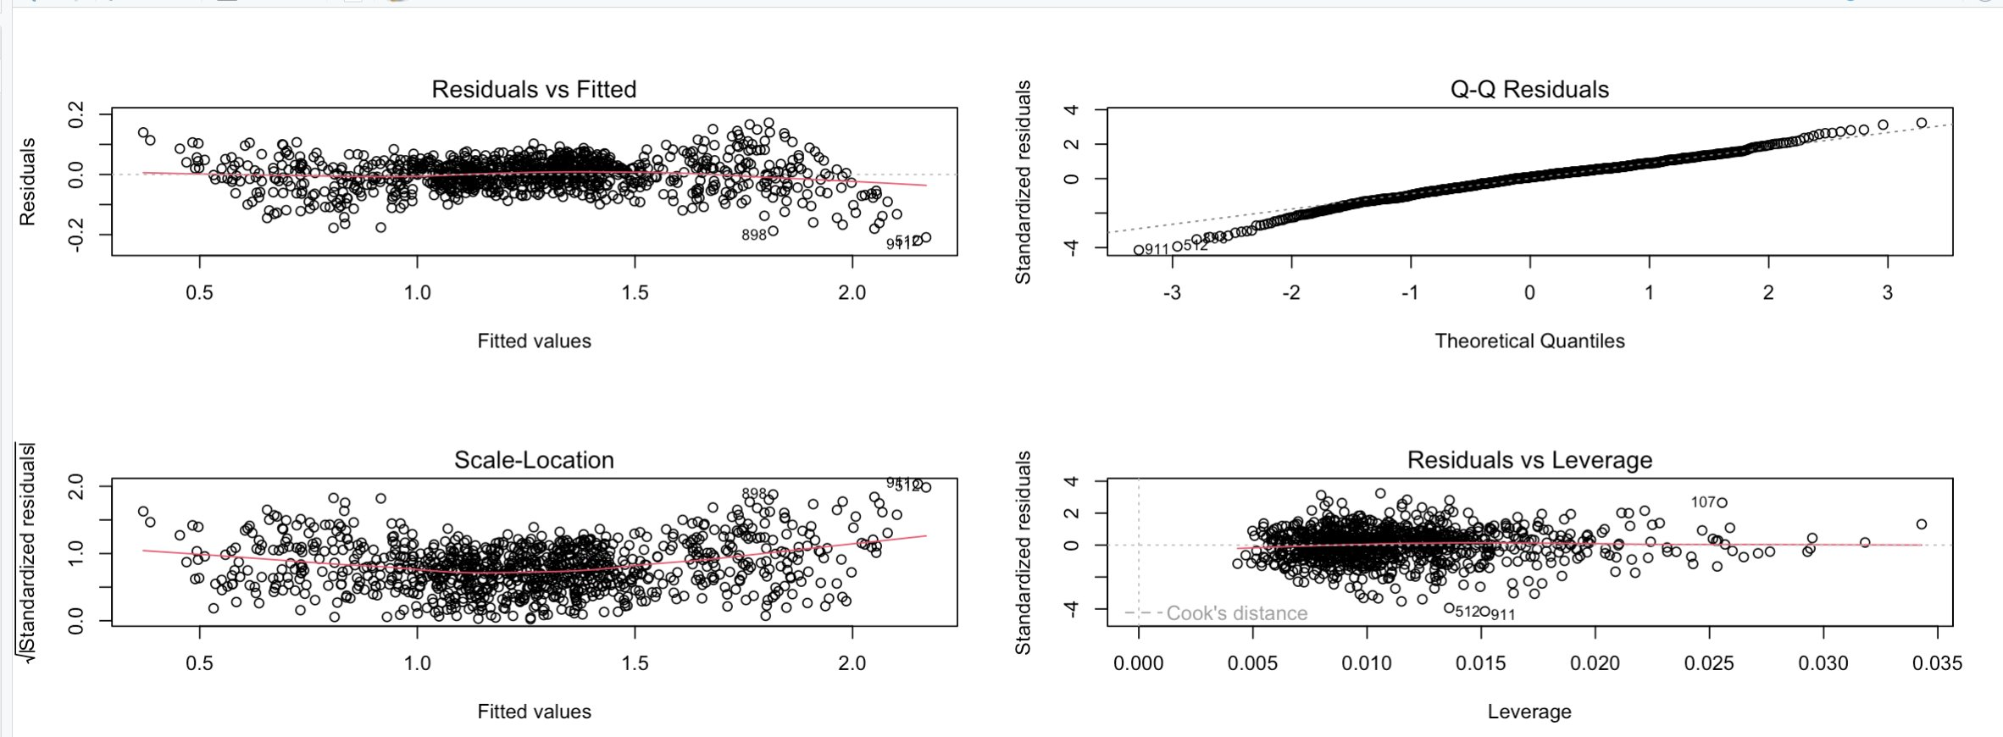
Scale-Location plot shows the relationship is linear because red line is close to horizontal.
Q-Q plots show the data is normally distributed because the data points don't deviate from reference line.
The red residual line is not curved in residuals vs Fitted plot, so the data is linear.
Some data points are influential, but there are fewer outliers.
Using the model to predict responses
What is the predicted Calories_Burned associated with a Session_Duration of 1.13 hours?

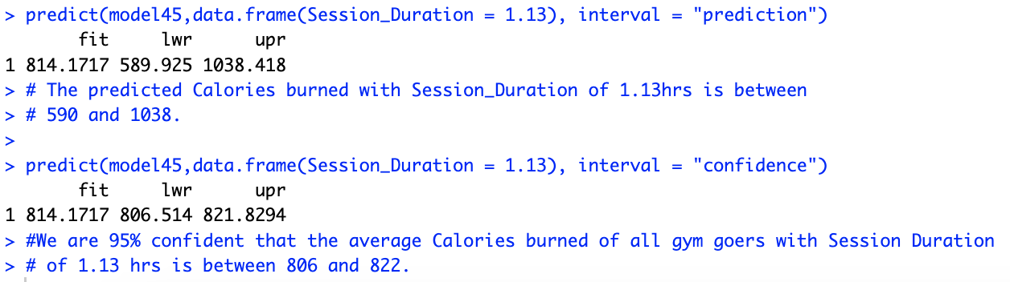
What is the predicted Session_Duration associated with a CaloriesBurned of 800?

model40 <- lm(Session_Duration~Calories_Burned, data = gym) summary(model40)
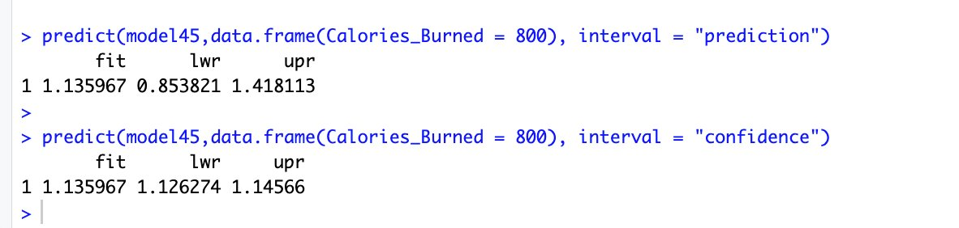
We are 95% confident that the Session_Duration of a gym goers with Calories_Burned of 800 is between (.85, 1.418) hours.
We are 95% confident that the average Session_Duration of all people with
Calories_Burned of 800 is between (1.126, 1.146) hours.

Insights from the multiple regression test and analysis: In conclusion, Calories_Burned and Experience_Level were the most significant predictors of session duration. In order to burn more calories, you need to have a higher session duration and be heavier. If you are more experienced, then you are more likely to spend more time per session at the gym.
Section 6: What We Learned
Throughout this project, our team gained valuable hands-on experience with the complete data analytics workflow from cleaning raw data to building predictive models. We began by selecting a publicly available dataset from Kaggle focused on gym members’ physical activity and body metrics. After importing and cleaning the dataset, we standardized column names, converted relevant variables to factors, and ensured the dataset was structured appropriately for analysis. We developed clear research hypotheses and applied ANOVA tests to compare multiple groups means such as calories burned across workout types and fat percentage across workout frequencies. During this process, we learned how to assess key assumptions like normality and homogeneity of variance using Shapiro-Wilk and Levene’s tests, and how to visualize distributions using QQ plots and boxplots. We also interpreted post-hoc Tukey HSD test results to identify which group differences were statistically significant.
Moving into multiple linear regression, we explored which predictors significantly influence session duration at the gym. We first created a full model with all predictors and interaction terms, then refined it by removing non-significant variables to improve interpretability and accuracy. This process taught us how to evaluate model fit using adjusted R-squared and F-statistics, how to perform diagnostic checks (like residual plots), and how to use models to make predictions with both confidence and prediction intervals.

Finally, we discussed the practical implications of our findings. For example, we saw that experience level and calories burned were strong predictors of session duration. This insight could help gym trainers design better programs by focusing on those variables. We also learned that adjusting or manipulating certain predictors such as BMI, workout frequency, or resting heart rate can meaningfully impact predicted outcomes, which demonstrates how data modeling can inform future decision-making.

Section 7: Key Insights from the Analysis
The statistical analysis produced several key insights regarding workout behavior and fitness outcomes.:
• Workout type does not significantly affect calories burned, suggesting that different workout styles produce similar average energy expenditure.
• Workout frequency significantly affects body fat percentage. Individuals who exercise more days per week tend to have lower body fat percentages.
• Experience level and calories burned were strong predictors of session duration in the regression model.
• The regression model explained a large proportion of the variation in session duration (Adjusted R² ≈ 97.6%), indicating strong predictive capability.
• Overall, the results highlight the importance of workout frequency, experience level, and energy expenditure in understanding fitness outcomes.

Section 8: Appendix: Team Meeting Log
Throughout the duration of this project, our team met regularly both in person and virtually to coordinate responsibilities, review progress, and troubleshoot analytical challenges. Each team member contributed meaningfully to various parts of the project, including dataset exploration, statistical testing, model development, and presentation design.
Jivitesh Marken: Dataset overview, and hypotheses formulation, ANOVA test
Niranjan K C: Problem definition, ANOVA, interpretation, visualizations, R code , Anova tests, and final model interpretation
Pradip Raj Dhakal: Multiple linear regression models, diagnostics, Anova tests, and final model interpretation

